**Instructions for requesting access to FMIS -**

The FMIS access request process has now been moved to EARS (Enterprise Access Request System)

In order to request access to FMIS click on the link "User ID Request" on the Tech Support Tab of http://cfo.fmis.gsa.gov/index.htm.

1. Or click on the following URL ---> <https://ears.ocfo.gsa.gov/ears/faces/home.jsp>
2. Log in using your ENT credentials (What you would log into your PC or Laptop when not using the HSPD-12 Card)
3. Click on the **"Profile Update"** tab and make sure your information is correct and your Manager/Supervisor is accurately reflected in the provided information.

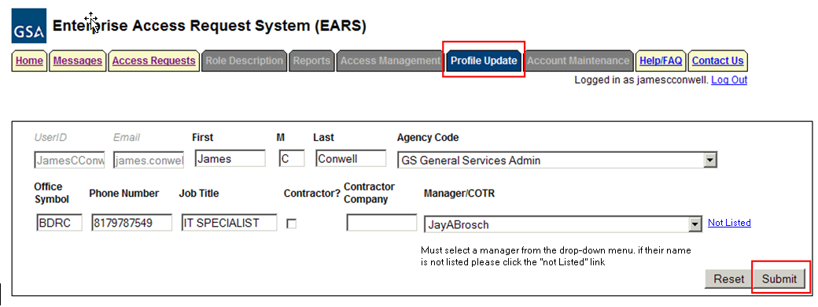

* If not then search for his/her name and make the modification.
* **\*Note**
* If your manager/supervisor's ENT account is not present, you must request that he/she is added to the list of supervisors.
* To do this send an email requesting your manager to be added:

Email Address: [ears.support@gsa.gov](mailto:ears.support@gsa.gov)

Subject: EARS Support Request

UserID: Your ENT User ID

Email: Your Email Address

Manager/COTR: Your Manager or COTR (Contractor) Name

Manager/COTR Email: Your Manager or COTR (Contractor) Email Address

* Once you have received an email from EARS Support notifying you of your manager’s addition to EARS please update your profile as instructed above and proceed with your access request.

1. After validating/updating your Profile you must request access by clicking on the **"Access Requests"** Tab.

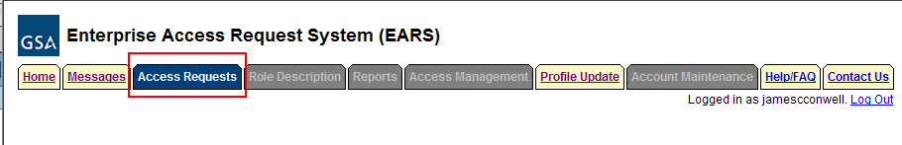

1. In the "Action*" option choose "New".
2. In the "System" option choose "FMS NEAR"
3. In the "Subsystem" choose "FMIS Read-Only"
4. If you want to include remarks in the "Remarks/Comments" Section please feel free to do so.

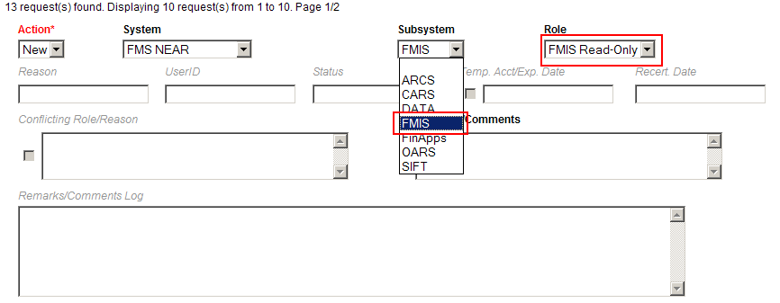

User Security Verification

* Initial Background Investigation * – Required to submit an access request. If received, check the Completed box and enter the Date completed. This is required only once per UserID.
* Full Background Investigation – Optional field. If user has received a full background investigation, check the Completed box and enter the Date completed.
* GSA Rules of Behavior * – Required to submit an access request (also required to be reviewed on an annual basis). The link will direct you to the current GSA Rules of Behavior; once reviewed, check the Accept button as acknowledgement that you agree to adhere to the rules of behavior. Enter the Date reviewed or completed.
* Non-Disclosure – If you checked the Contractor box, this becomes a required field. Check the Completed box and enter the Date completed which signifies that you have reviewed/signed the NDA and given to your COTR.
* Attachments – The first attachment box allows the user to ‘view’ existing attachments. The second box allows the user to ‘add’ an attachment (i.e. email of background investigation for audit support)

Finishing up

* Once you have filled in the appropriate information Verify that your information is correct and click "Submit".
* Your manager/supervisor will receive an email notifying them that the request has been submitted.